|  |  |
| --- | --- |
| MMB 2.628px-Uppsala_Universitet_Logo_svg13 | |
|  | POST1 |
|  | Tutorial |
|  |  |
|  |  |

**Copyright and Permission Notice**

Copyright (c) 2009 Samuel Flores, Stanford University

Contributors: Joy P. Ku

For full copyright and permission notice, see the *Reference guide.*

**Acknowledgments**

Early development of RNABuilder was funded by the [Simbios](http://simbios.stanford.edu) National Center for Biomedical Computing through the National Institutes of Health Roadmap for Medical Research, Grant U54 GM072970. Information on the National Centers can be found at <http://nihroadmap.nih.gov/bioinformatics>. Ongoing development of MMB is funded by Uppsala University, Sweden.

**Table of Contents**

1 Overview 9

2 Prerequisites and installation instructions 11

3 Exercise 0: Your first MMB run 15

3.1 Objectives 15

3.2 Verify you have the required files 15

3.3 Open a command prompt/terminal window 16

3.4 Navigate to your MMB folder 16

3.5 Run MMB 17

3.6 Visualize MMB results 18

4 Exercise 1: Generating your first 3D model 21

4.1 Objectives 21

4.2 Examining and editing the input parameters file 21

4.2.1 RNA and protein sequence commands 22

4.2.2 Stage parameters 22

Run parameters 23

4.2.3 Temperature 25

4.2.4 randomizeInitialVelocities 25

4.2.5 Base pairing force commands 25

4.2.6 Global simulation parameters 27

5 Exercise 2: Reading structures from a PDB file and rigidifying parts of your model 31

5.1 Objectives 31

5.2 Rigid mobilizers and Weld constraints 32

5.3 SelectedAtoms 33

5.4 Run example 34

5.5 On your own: Determine the effects of the Weld constraints and rigidification 34

5.6 On your own: Turn the RNA into a different 3D structure 35

6 Exercise 3: Threading Azoarcus to Tetrahymena Ribozyme P6ab 37

6.1 Objectives 37

6.2 Specifying the target 37

6.2.1 Read in the PDB file for the target 37

6.2.2 Specify target sequence to match information in the PDB file 38

6.2.3 Rigidify the target 38

6.3 The threaded chain 38

6.3.1 Specify the sequence of the threaded chain 38

6.3.2 Account for sterics using AllHeavyAtomSterics Contact forces 39

6.4 Apply forces to pull the corresponding residues together 39

6.5 Run example 40

7 Exercise 4: Protein threading 42

7.1 Objectives 42

7.2 Specifying the target 42

7.2.1 Provide the PDB file for the target 42

7.2.2 Start the run 43

7.2.3 Specify template sequence to match information in the PDB file 43

7.2.4 Specify model sequence, for which no structural information is available 43

7.2.5 Rigidify the template and constrain it to ground 43

7.2.6 Align the model and template backbones 44

7.2.7 Apply sterics to the model chain 44

8 Exercise 5: Protein morphing 47

8.1 Objectives 47

8.2 Introduction 47

8.3 Preparing the input structure file 47

8.4 Start the run 48

8.5 Examine the input file 48

8.6 On your own: complete the morph with a fully-flexible alignment 51

9 Exercise 6: Efficiently generate alternate protein conformations 53

9.1 Objectives 53

9.2 Introduction 53

9.3 The command file 54

9.4 Run MMB 54

9.5 Analyze the conformational coverage 54

10 Exercise 7: Solve protein structure by NMR constraints 57

10.1 Objectives 57

10.2 Instructions 57

10.3 Results 61

11 Exercise 8: Fitting to electron density maps 62

11.1 Objectives 62

11.2 Introduction 62

11.3 Run MMB 63

11.4 The command file 64

11.5 View the results 65

11.6 On your own 66

12 Virtual assembly of a protein-DNA complex 68

12.1 Objectives 68

12.2 Introduction 68

12.3 Run MMB 68

12.4 The command file 69

12.5 View the results 71

12.5.1 Symmetry expansion with PyMOL 71

12.5.2 Symmetry expansion using other tools 72

# 

# Overview

MMB constructs 3D structural and dynamical models of RNA and protein by applying user-specified base pairing interactions, interatomic forces, sterics, bond mobilities, and structural constraints. The forces, constraints, mobilities, parameters, and molecules can change from one simulation stage to another. It uses multi-resolution techniques, such as coarse-grained force fields and selective rigidification of groups of atoms, to decrease computation time.

MMB is run from the command line and requires a user-provided input parameter file that specifies the simulation, and optionally an input structural coordinate file in PDB format. It produces trajectory files, also in PDB format.

MMB was written in C++ code using Simbody and its molecular modeling extension, [Molmodel](https://simtk.org/home/molmodel). Binary installations are available for Windows, Intel-based Mac, and Linux. The source code is also freely available for download.

For a summary of what is new in this release, and for citation info, please see the Reference Guide.

# Prerequisites and installation instructions

You will need VMD (or equivalent) plus the MMB executable and auxiliary files to do the exercises in this manual:

1. **VMD (or another software for viewing trajectory files):** We have experienced some problems installing VMD 1.8.7 on Windows. VMD 1.8.6 or Pymol can also be used.

To install VMD, go to [http://www.ks.uiuc.edu/Research/vmd](http://www.ks.uiuc.edu/Research/vmd" \t "_blank). Click on "Download VMD" and select the installation for your platform. Follow the on-line instructions for installing.

1. **MMB:** MMB is a tool for building 3D RNA and protein models using a variety of knowledge the user has about the structure. It runs from the command line (don’t expect a graphical interface!) and requires a user-generated input file and an MMB parameter file (more details below). The main output of MMB is the trajectory it generates from the provided parameters, in PDB format. The last frame of the trajectory is also saved as a PDB file.

You can download MMB from <http://simtk.org/home/rnatoolbox>. Click on “Downloads.” You should now be at: <https://simtk.org/project/xml/downloads.xml?group_id=359> . Follow the directions for your operating system below to install and test MMB.

**Windows:**

For Windows, download Installer.2\_13.Windows.zip . Find it in Windows Explorer (a Windows Explorer window probably opened automatically when you downloaded the package). Right-click on Installer.2\_13.Windows.zip and click on “Extract to the specified folder” in the mouse menu. In the “Destination path,” type “C:\Users\Installer.2\_13.Windows”, or some other path of your choice. Don’t extract it in “Program Files,” because on some Windows flavors this directory does not allow writing output files. Version 2.4 is not yet available for Windows, so Windows users will not be able to do all of the examples, in particular Exercise 8 (fitting to density maps).

**MacOSX:**

If you are running Leopard or later, download and save the file Installer.2\_13.OSX.tgz. Move this file to another location – we suggest your home directory, in mac that would be /Users/[your-user-name] , in Linux that would be /home/[your-user-name], or you can just use the Linux/Unix shortcut “~”; that’s what we will do in this tutorial.

Now, open a Terminal window. You will find the Terminal application in:

Macintosh HD -> Applications -> Utilities -> Terminal

You will now decompress the above file. In Terminal, issue:

cd ~

tar -zxvf Installer.2\_13.OSX.tgz

The files will be decompressed into the ~/Installer.2\_13[OSX | Ubuntu\_32Bit] directory.

Now, you just need to tell OSX where to find the library files. That’s easy, all the MMB files are in the same directory. You can specify this in your ~/.bash\_profile or wherever you put your configuration file, or just do it manually every time you run MMB. In bash the command is:

export DYLD\_LIBRARY\_PATH=/Users/[your-user-name]/Installer.2\_13.OSX

export LD\_LIBRARY\_PATH=/home/[your-user-name]/Installer.2\_13.Ubuntu\_32Bit

Note that you can’t use the “~” shortcut in your .bash\_profile .

Make sure you issue source ~/.bash\_profile if you went that route. Now you’re ready to go!

**Linux (32 Bit):**

If you are using Ubuntu, download and save the file:

Installer.2\_13.Ubuntu32.tgz

If you have a different distribution of Linux, download this file anyway and let me know if it works; otherwise we may have to install from source.

Decompress by issuing:

tar –zxvf Installer.2\_13.Ubuntu32.tgz

This will unpack into a directory called Installer.2\_13[OSX | Ubuntu\_32Bit]. Move this directory to the location of your choice. In this tutorial we will assume you moved it into ~.

You should be in the bash shell. You can figure out what shell you’re using by issuing echo $SHELL . If you’re not in bash, issue : bash .

Now, you just need to tell Linux where to find the library files. That’s easy, all the MMB files are in the same directory. You can specify this in your ~/.bash\_profile or wherever you put your configuration file, or just do it manually every time you run M. In bash the command is:

export LD\_LIBRARY\_PATH=~/Installer.2\_13.Ubuntu32

.. or wherever you installed the package. Make sure you issue source ~/.bash\_profile if you went that route. Now you’re ready to go!

**Linux (64 Bit):**

The instructions are mostly the same as for 32-bit Linux. Except you will download:

Installer.2\_13.Linux64.tgz

Again unzip it in ~. Then:

export LD\_LIBRARY\_PATH=~/Installer.2\_13.Linux64

It may also search for liblapack.so.3 and libblas.so.3, which appear to go under the name lib\*.so.3gf on some debian derivates. Some of our users have reported that this is dealt with by just making symlinks with the .so.3 suffixes for MMB to run. Throughout this tutorial, just follow the Linux 32-Bit instructions, issuing MMB.2\_13.Linux64 instead of MMB.2\_13.Ubuntu32 .

# Exercise 0: Your first MMB run

## Objectives

This first exercise is intended for you to:

* Learn how to invoke MMB
* Verify that your installation is working properly
* Learn how to visualize the M-generated trajectory within VMD

## Verify you have the required files

MMB requires two files in order to run:

* *parameters.csv*: This is a parameter file, analogous to those used by molecular dynamics programs to set bond, stretch, bend, torsion, etc. parameters.  One of the main differences is that the parameters.csv specifies the rotation and translation relating the glycosidic nitrogen atoms in interacting pairs of bases.  Casual users are unlikely to modify this file.

On Windows, this file should have been copied from the latest examples folder into your MMB folder.

* An input file: This text file specifies the sequence, base pairs, and any other constraints, forces, and options that should be applied. In this exercise, we will use *commands.singlebasepair.dat*.

Verify that you have these two files in your MMB folder. The default/recommended locations for your MMB folder are:

*(Windows)* My Computer -> C: -> Users -> Installer.2\_13.Windows

*(Mac OSX)* ~/Installer.2\_13.OSX

*(Linux)* ~/Installer.2\_13.Ubuntu32

## Open a command prompt/terminal window

MMB is run from the command prompt/terminal/console. If you haven’t already done so, to launch a command prompt/terminal window, select:

*(Windows)* Start -> All Programs -> Accessories -> Command Prompt

*(Mac OS)* Macintosh HD -> Applications -> Utilities -> Terminal

*(Linux)* Open the Console that comes with your distribution.

## Navigate to your MMB folder

For these exercises, we will be running MMB from the MMB folder. It is possible to run MMB from other directories, but the directory must contain the *parameters.csv* parameter file.

Within the command prompt/terminal window/console, navigate to the MMB folder. If you installed in the default locations, you would type:

*(Windows)* cd “C:\Users\Installer.2\_13.Windows”

*(Mac OSX)* cd ~/Installer.2\_13.OSX

*(Linux)* cd ~/Installer.2\_13.Ubuntu32

**Note:** Quotation marks are required in specifying directory paths within the Windows command prompt window if the directory path includes spaces.

## Run MMB

To run MMB, type:

*(Windows)* MMB.2\_13.exe -c commands.singlebasepair.dat

*(Mac OS)* ./MMB.2\_13.OSX -c commands.singlebasepair.dat

*(Linux)* ./MMB.2\_13.Ubuntu32 -c commands.singlebasepair.dat

For OSX, you have a choice of executables depending on what version you’re using. The –c option specifies the input file name, in this case *commands.singlebasepair.dat*.

Note: If you do not specify the –c option, MMB uses a default input file name of *commands.dat*.

You should see output that looks something like this:

[TwoTransformForces.cpp] Satisfied contacts : 0 out of : 1

Writing structure for reporting interval # 1

[TwoTransformForces.cpp] Satisfied contacts : 0 out of : 1

Writing structure for reporting interval # 2

[TwoTransformForces.cpp] Satisfied contacts : 0 out of : 1

Writing structure for reporting interval # 3

...

If instead you see messages like the following:

/Users/Sam/svn/RNAToolbox/trunk/src/ParameterReader.cpp:2312 Unable to open command file: commands.singlebasepair.dat

MMB could not find the input file you specified (in this case *commands.singlebasepair.dat*). Make sure you spelled the file name correctly and that it exists in the directory from which you are calling MMB.

## Visualize MMB results

MMB generates a number of files that by default are saved to the directory from which you ran MMB. You should see a *last.1.pdb* file and a *trajectory.1.pdb* file. *last.1.pdb* is the PDB file for the last frame in the trajectory, which is typically the most interesting for structure prediction. The entire trajectory is saved in NMR format in the file *trajectory.1.pdb*.

We can visualize the resulting trajectory within VMD:

1. Launch VMD. If you installed VMD in typical locations, you would select:

*(Windows)* Start -> All Programs -> University of Illinois -> VMD -> VMD 1.8.7

*(Mac OS)* Macintosh HD -> Applications -> VMD

*(Linux)* The location may depend on your distribution.

1. The “VMD Main” window will appear. Select:

File -> New Molecule…

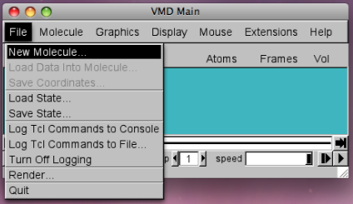 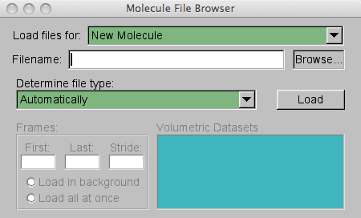

1. In the “Molecule File Browser” that appears, click on “Browse” and select the *trajectory.1.pdb* created by MMB. The location for this file (for default/recommended installations) is:

*(Windows)* My Computer -> C: -> Users -> Installer.2\_13.Windows

*(Mac OSX)* ~/Installer.2\_13.OSX

*(Linux)* ~/Installer.2\_13.Ubuntu32

1. Change the molecule representation by going to the “VMD Main” window and selecting:

Graphics -> Representations

From the drop-down menu for “Drawing Method,” select “Licorice.” (In VMD 1.8.7, you might want to try the “New Cartoon” method, which provides a nice visualization of the molecule).

1. You should see a structure like that shown below by the end of the trajectory (the “Licorice” drawing method was used). In this simple example, a single base pair was specified pulling the two ends together.

To rotate the structure, click and drag the structure. To translate the structure, type t and then click and drag the structure. To return to rotating the structure, type r.

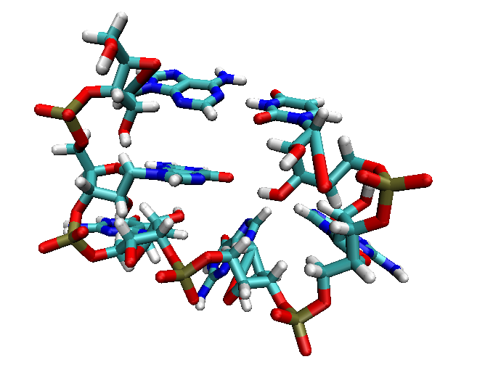

# Exercise 1: Generating your first 3D model

## Objectives

In Exercise 1, you will:

* Learn about some of the key parameters that need to be specified within the command file
* Use your new knowledge about MMB to build a GNRA tetraloop from a starting sequence and published geometric constraints

## Examining and editing the input parameters file

To edit or create and input parameters files, you must use a text editor (NOT a program like Microsoft Word, which will add many hidden characters for formatting, etc.) For Windows, we recommend using WordPad (Start -> All Programs -> Accessories -> WordPad). On Mac, some options include vi, emacs, and TextEdit (Macintosh HD -> Applications -> TextEdit.app).

Start your text editor and open up the file *commands.hairpin-short.dat*, located in your MMB folder. The default locations for your MMB folder are:

*(Windows)* My Computer -> C: -> Users -> Installer.2\_13.Windows

*(Mac OSX)* ~/Installer.2\_13.OSX

*(Linux)* ~/Installer.2\_13.Ubuntu32

The syntax of the input parameters file is that each row contains information about one particular parameter. The first word in the row is the name of the parameter, followed by one or more values needed to specify that parameter.

### RNA and protein sequence commands

The first section of the *commands.hairpin-short.dat*  file contains the sequence parameters, described below. The baseInteraction records (discussed later) must appear sometime *after* the firstResidueNumber of each interacting chain in the base pair has been specified. firstResidueNumber must appear sometime *after* the corresponding sequence has been specified. Other than that, the order in which parameters are listed usually does not matter, except in some advanced usages not covered in this tutorial.

|  |  |
| --- | --- |
| RNA A 2656 UACGUAAGGA | To instantiate a biopolymer, use RNA , DNA or Protein command. This takes the following parameters: chain ID (string, single character long), first residue number (integer), and sequence (string, single letter code).  This example instantiates an RNA chain with chain identifier "A", first residue number 2656, and the sequence shown in single-letter code. The chain identifier should be a single character in compliance with the PDB format. The sequence can be quite long, dependent mostly on your available memory. If you are supplying an input PDB structure file, the coordinates will be matched according to the chain ID and residue number. |

### Stage parameters

MMB can divide up the simulation into stages, each with its own set of simulation parameters. This allows flexibility in how the simulation is performed. Stages are explained in more detail in Exercise 2. In this exercise, we will not be dividing up the simulation into stages, so the first stage and the last stage are the same:

firstStage 1

lastStage 2

This starts the simulation at stage 1, and ends when stage 2 is over.

### Run parameters

The next section of the *commands.hairpin-short.dat*  file specifies the run parameters, which control the bookkeeping aspects of the MMB simulation.

#### baseInteractionScaleFactor

The baseInteractionScaleFactor (alias forceMultiplier, twoTranformForceMultiplier) is a scaling factor applied to the baseInteraction forces and energies. The base pairing forces themselves are applied using the following scheme.

First, an *attachment frame* is generated which is part of the first residue’s glycosidic nitrogen body, but located outside it. Then a *body frame* is generated which is located at the center of the second residue’s glycosidic nitrogen. The *body frame’*s x-axis points along the glycosidic bond, and its z-axis is perpendicular to its base plane. The location and orientation of the *attachment frame* is such that when it is aligned with thesecond residue’s *body frame* the desired base pairing geometry is attained. Thus the task of parameterizing the MMB force field is firstly that of determining the correct position and orientation of the *attachment frame.* We distribute a program to compute this given the coordinates of a base pair with the desired geometry, but will not cover its use in this tutorial. After this is done one must also determine the depth of the potential well and its range – again beyond the scope of this tutorial.

In this exercise, baseInteractionScaleFactor was set to 20, to make the forces strong enough for convergence:

baseInteractionScaleFactor 20

Note that it is not good idea to make the force multiplier *too* strong, because this will make the system stiff, which means there will be fast oscillations which will in turn require the variable time step integrator to take small time steps. If the baseInteractionScaleFactor parameter is not specified, it defaults to 1.

#### reportingInterval

This parameter controls the frequency of trajectory frames (reporting intervals) written by MMB.

|  |  |
| --- | --- |
| reportingInterval 4.0 | This instructs MMB to output a trajectory frame for every 4.0 ps of simulation time, starting at time 0 |

### Temperature

In the *commands.hairpin-short.dat*  file, the temperature parameter is specified:

|  |  |
| --- | --- |
| temperature 20.0 | This sets the temperature of the simulation to 20.0 |

If setTemperature is set to TRUE, as it is by default, MMB uses one of several available thermostat algorithms (set by thermostatType, which defaults to NoseHoover) to hold the system temperature to this setpoint. Note that thermostats do not conserve system energy.

### randomizeInitialVelocities

When set to TRUE, random initial velocities are assigned to each degree of freedom in the system (initial velocities would otherwise all be zero). This is good if you want some stochasticity in your system, which is useful for conformational searches. It also means that the results will change every time you run your script.

### Base pairing force commands

The base pairing forces pull bases into specific geometric configurations. The syntax is:

baseInteraction <chain identifier for first residue>

<residue number for first residue>

<interacting edge for first residue>

<chain identifier for second residue>

<residue number for second residue>

<interacting edge for second residue>

<glycosidic bond orientation>

In the *commands.hairpin-short.dat*  file, you will see three lines creating three base pairing forces:

baseInteraction A 2658 WatsonCrick A 2663 WatsonCrick Cis

baseInteraction A 2657 WatsonCrick A 2664 WatsonCrick Cis

baseInteraction A 2656 WatsonCrick A 2665 WatsonCrick Cis

The first line specifies an interaction between the Watson-Crick edges of residues 2658 and 2663 of chain A, with the glycosidic bonds in the Cis orientation. See *Appendix: Forces* for an explanation of this type of interaction. See the same appendix for the other supported combinations of base pairing parameters.

When MMB sees three or more WatsonCrick/WatsonCrick/Cis interactions applied to three consecutive residues on each of two strands, it will automatically apply stacking interactions (HelicalStackingA3/HelicalStackingA5/Cis) to the consecutive residues (in this case 2656-2657, 2657-2658, 2663-2664, and 2664-2665). Thus the total number of baseInteraction’s in the system is 3+4 = 7. MMB monitors how many of these are approximately satisfied at each reporting interval, as you will see.

#### Using stages

MMB divides the simulation into stages, each with its own set of simulation parameters. The first stage is run using information solely from the input parameters file. Since there is no structure, all biopolymers are instantiated as extended chains. The last structure in this stage is written out to the file *last.1.pdb*. This *last.1.pdb* is the starting structure for stage 2 of the simulation. Similarly, at the end of stage 2, the file *last.2.pdb* is written out and used as the starting structure for stage 3. This process repeats for as many stages as specified.

Note that we can use this to start MMB using *any* PDB structure file. In the above explanation, firstStagewas set to 1, but there’s nothing stopping us from setting it to a higher stage and reading in an arbitrary structure file, as follows:

1. Renaming the desired PDB file to *last.1.pdb.* Make sure the chain ID and residue numbering in the PDB file match that in the command file.
2. Setting the parameter firstStageto 2
3. lastStage would also need to be greater than or equal to 2

But let’s not do that now! It will be part of a future exercise.

For now, we will use stages to change our simulation parameters, as we explain next.

#### Turning any parameter into a staged parameter

Any parameters or commands can be enclosed in readAtStage … readBlockEnd

tags. This means that the enclosed parameters will be read only for the specified stage. So if you want to read certain values for parameter1, parameter2, etc only during stages 3, do this:

readAtStage 3

*parameter1 value1*

*parameter2 value2*

*…*

readBlockEnd

You can have as many of these blocks as you wish, and use them to change the parameters at many stages. There are some other block markers which behave differently (e.g. readFromStage, readToStage, readUntilStage, readExceptAtStage), see the *Reference guide*. Also, there are a few nuances to keep track of. The input file is read from top to bottom. Parameters encountered more than once in the input file are overwritten with the one closer to the bottom of the file prevailing. Commands (e.g. baseInteraction), on the other hand, are additive, rather overwriting each other. See also Appendix: Forces.

In this tutorial the first stage is very short – we are creating a hairpin without concern for steric clashes:

readAtStage 1

numReportingIntervals 10

readBlockEnd

So we are specifying that at stage 1, we will run for 10 reporting intervals. Note that total simulation time = numReportingIntervals\*reportingInterval .. so for stage 1 simulation time is 40 ps.

### Global simulation parameters

The next section of the *commands.hairpin-short.dat*  file specifies global simulation parameters, properties that apply to the overall simulation.

|  |  |
| --- | --- |
| numReportingIntervals 200 | This determines how many frames are generated. In this case, 60 intervals are requested, resulting in 61 frames representing a 60-ps simulation. |

#### The scrubber and collision-detecting spheres

Potential rescaling is the name given to the idea of scaling all forces by some factor, typically periodically, e.g. sinusoidally, or as here, with a rectangular wave. Within MMB we call this algorithm the “scrubber” since it will look like your molecule is being scrubbed violently. It’s quite useful for getting out of kinetic traps, which are common in structure prediction.

The scrubberPeriod parameter specifies the duration of one cycle (forces on + forces off) in ps, while the dutyCycle specifies the ratio of time forces are active, to total time: (force on)/(force off + force on). It’s not a bad idea to set scrubberPeriod = n \* reportingInterval, with n being an integer >= 1, so you can see the results of the scrubber in your output trajectory. In practice might play with these parameters, as well as temperature, baseInteractionScaleFactor, and others over one or more stages until you find settings that work with your problem.

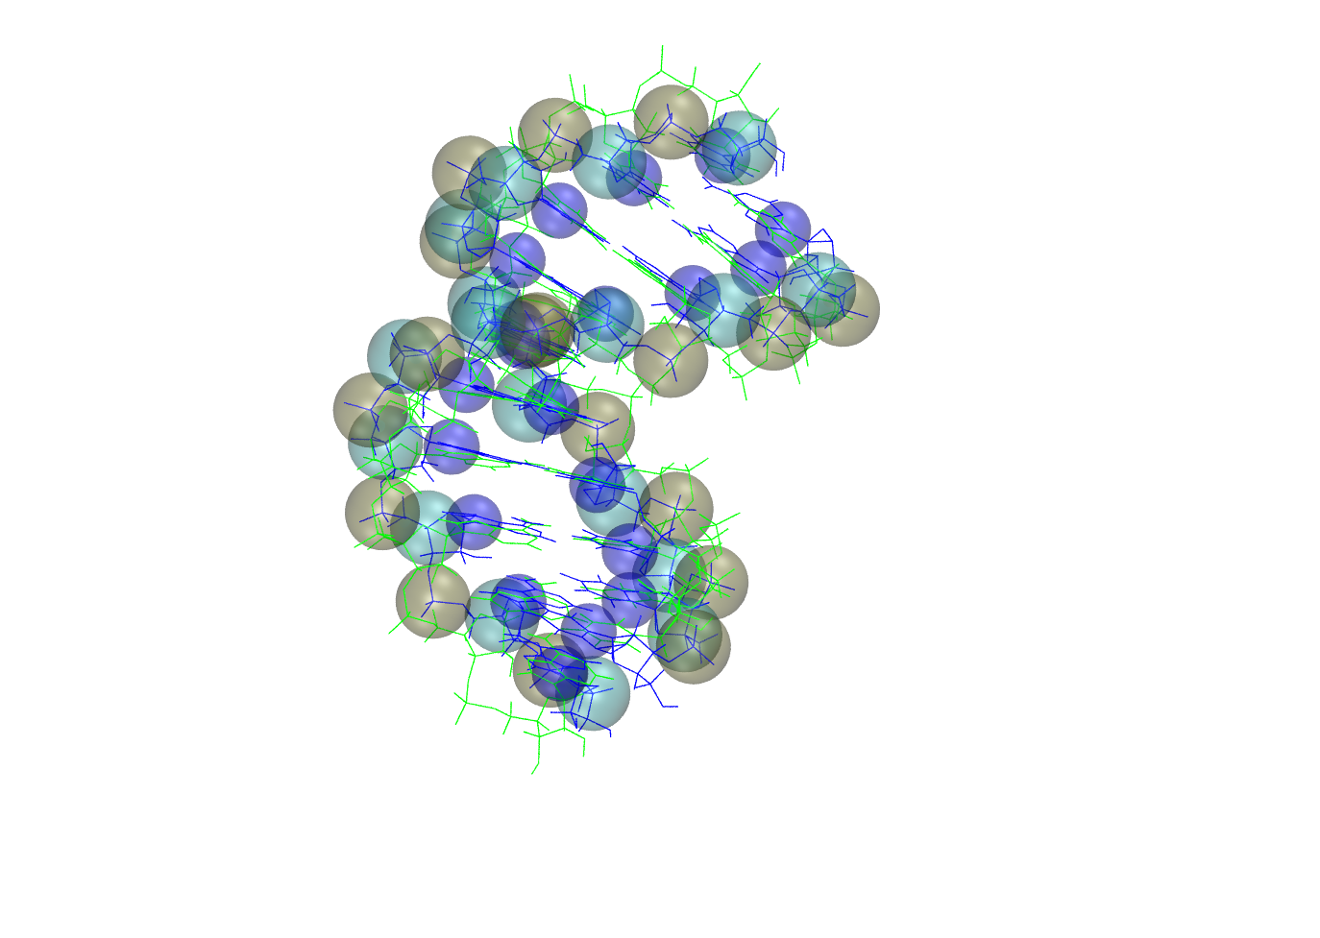

We also need to discuss collision-detecting (steric) spheres. These are soft spheres – non-interacting until the center-to-center distance is less than the sum of the radii, at which point a repulsive force is applied to each of the two spheres along the center-to-center axis. These are implemented very efficiently in Simbody, the internal coordinate mechanics engine underlying MMB. Several schemes are available. The figure shows the SelectedAtoms scheme, which applies thee spheres to each nucleic acid residue. We will use AllHeavyAtomSterics, which applies one sphere of radius excludedVolumeRadius and stiffness excludedVolumeStiffness to all atoms except hydrogen.

At stage 2 in this example, we apply steric spheres and use the scrubber to get us out of any resulting kinetic traps:

readAtStage 2

dutyCycle .9

scrubberPeriod 40

contact AllHeavyAtomSterics A

readBlockEnd

You should at this point understand that at stage 2, we apply the scrubber with period of 40 ps and duty cycle of .9. The contact command here adds steric spheres to all heavy atoms in chain A – see the *Reference guide* for variations on this syntax.

#### Run example

In your command prompt/terminal window (see Exercise 0), type:

*(Windows)* dir

*(Mac OS, Linux)* ls

You will see a list of files in your current directory. Make sure you have *commands.hairpin-short.dat* and *parameters.csv*. If not, navigate to the directory with these files (see Exercise 0).

Now, run this example by typing:

*(Windows)* MMB.2\_13.exe -c commands.hairpin-short.dat

*(Mac OS)* ./MMB.2\_13.OSX -c commands.hairpin-short.dat

*(Linux)* ./MMB.2\_13.Ubuntu32 -c commands.hairpin-short.dat

The trajectories from this simulation run are in *trajectory.1.pdb* and *trajectory.2.pdb* files. The “1” and “2” in the output file names refer to the fact that the results are from stages 1 and 2. This trajectory can be loaded into and visualized with VMD (see Exercise 0. Make sure you first restart VMD or delete the molecule you loaded in that exercise). By the end of the trajectory, you should see a structure like that shown below. Notice how the 3 base pairs at the ends of the chain have been enforced to produce the hairpin structure. Note also the violent scrubbing to resolve knots in stage 2.

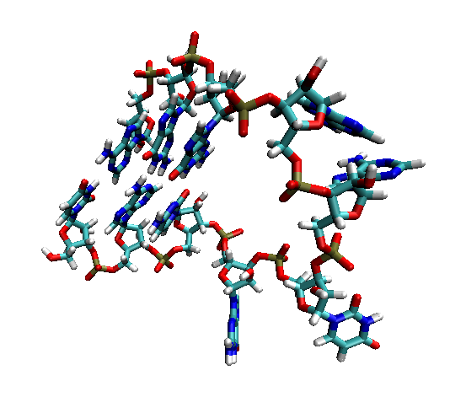

# Exercise 2: Reading structures from a PDB file and rigidifying parts of your model

## Objectives

In this exercise, you will:

* Learn how to use stages to read in and simulate a structure from a PDB file
* Learn about two new types of constraints that can be applied to your model: Weld and Rigid
* Experiment to see what happens when you release these constraints

In your MMB folder, you should see the following files: *1ARJ.short.pdb* and *commands.TAR.dat*. If you do not see them, make sure you are in your MMB folder (see Exercise 0).

*1ARJ.short.pdb* is the file that we want MMB to read in, so let’s copy it to a file named *last.1.pdb*. In your command prompt/terminal window, type:

*(Windows)* copy 1ARJ.short.pdb last.1.pdb

*(Mac OS, Linux)* cp 1ARJ.short.pdb last.1.pdb

Now, let’s look at the input parameters file. Open *commands.TAR.dat* in your text editor. Notice that firstStage and lastStage are both set to 2. Notice also that sequence and firstResidueNumber are set to match that of the TAR molecule. (You can compare the values for these parameters with the PDB entry for 1ARJ at <http://www.pdb.org/pdb/explore/remediatedSequence.do?structureId=1ARJ>).

## Rigid mobilizers and Weld constraints

MMB allows you to (1) fix a chain to ground, (2) weld two residues to each other, and (3) rigidify continuous stretches of residues.

(1) is useful for instances when you are not interested in the overall rotation and translation of a molecule, or when you expect that the 5’ end would be fixed in an experimental situation. (2) is often useful when two strands of a helix have been made rigid and now need to be fixed with respect to each other, or to fix the ends of a flexible loop to each other. (3) can be used, for example, to rigidify regions of a molecule to focus resources on a small region of interest, or to model the motion of domains about a flexible hinge.

Note that while (3) almost always saves computer time, (1) and (2) may actually increase it. The reason for this is that rigidification involves Rigid *mobilizers,* but welding specifies Weld *constraints.* The latter create constraint equations which must then be satisfied, while the former simply prevent internal degrees of freedom from being created in the first place. See the *Simbody* literature (<http://simtk.org/home/simtkcore> and look under “Documents”) for details on this. Also note that there are many more ways to control the bond mobilities in M, which we will not discuss in this tutorial.

The following parameter settings in the *commands.TAR.dat* show how to set up these different types of rigidification. Refer to the diagram on the next page for the residue numbering.

|  |  |
| --- | --- |
| removeRigidBodyMomentum False | By default, MMB removes the rigid body momenta and keeps the system center of mass at the origin. While this is useful to prevent the system from spinning or drifting, it is not compatible with constraints to Ground, so we will turn it off for this simulation. |
| constrainToGround N 17 | This command fixes the C3’ atom of the specified residue (here chain N, residue 17) to the ground frame. See *Appendix: Forces* for an alternative command. |
| mobilizer Rigid N 17 21  mobilizer Rigid N 41 45 | These two lines rigidify helix I except for the base pair adjacent to the bulge (residues 17 to 21 and residues 41 to 45). |
| mobilizer Rigid N 27 38 | The stretch of residues from 27 to 38 (most of helix II plus the loop) are rigidified. |
| constraint N 17 Weld N 45 | This line welds the two ends (residues 17 and 45) together. |
| constraintTolerance .001 | This line controls the fidelity with which Rigid and Weld constraints are enforced. A value of .001 means that all internal coordinates must be fixed within .001 nanometers or radians, depending on whether they are distances or angles. |

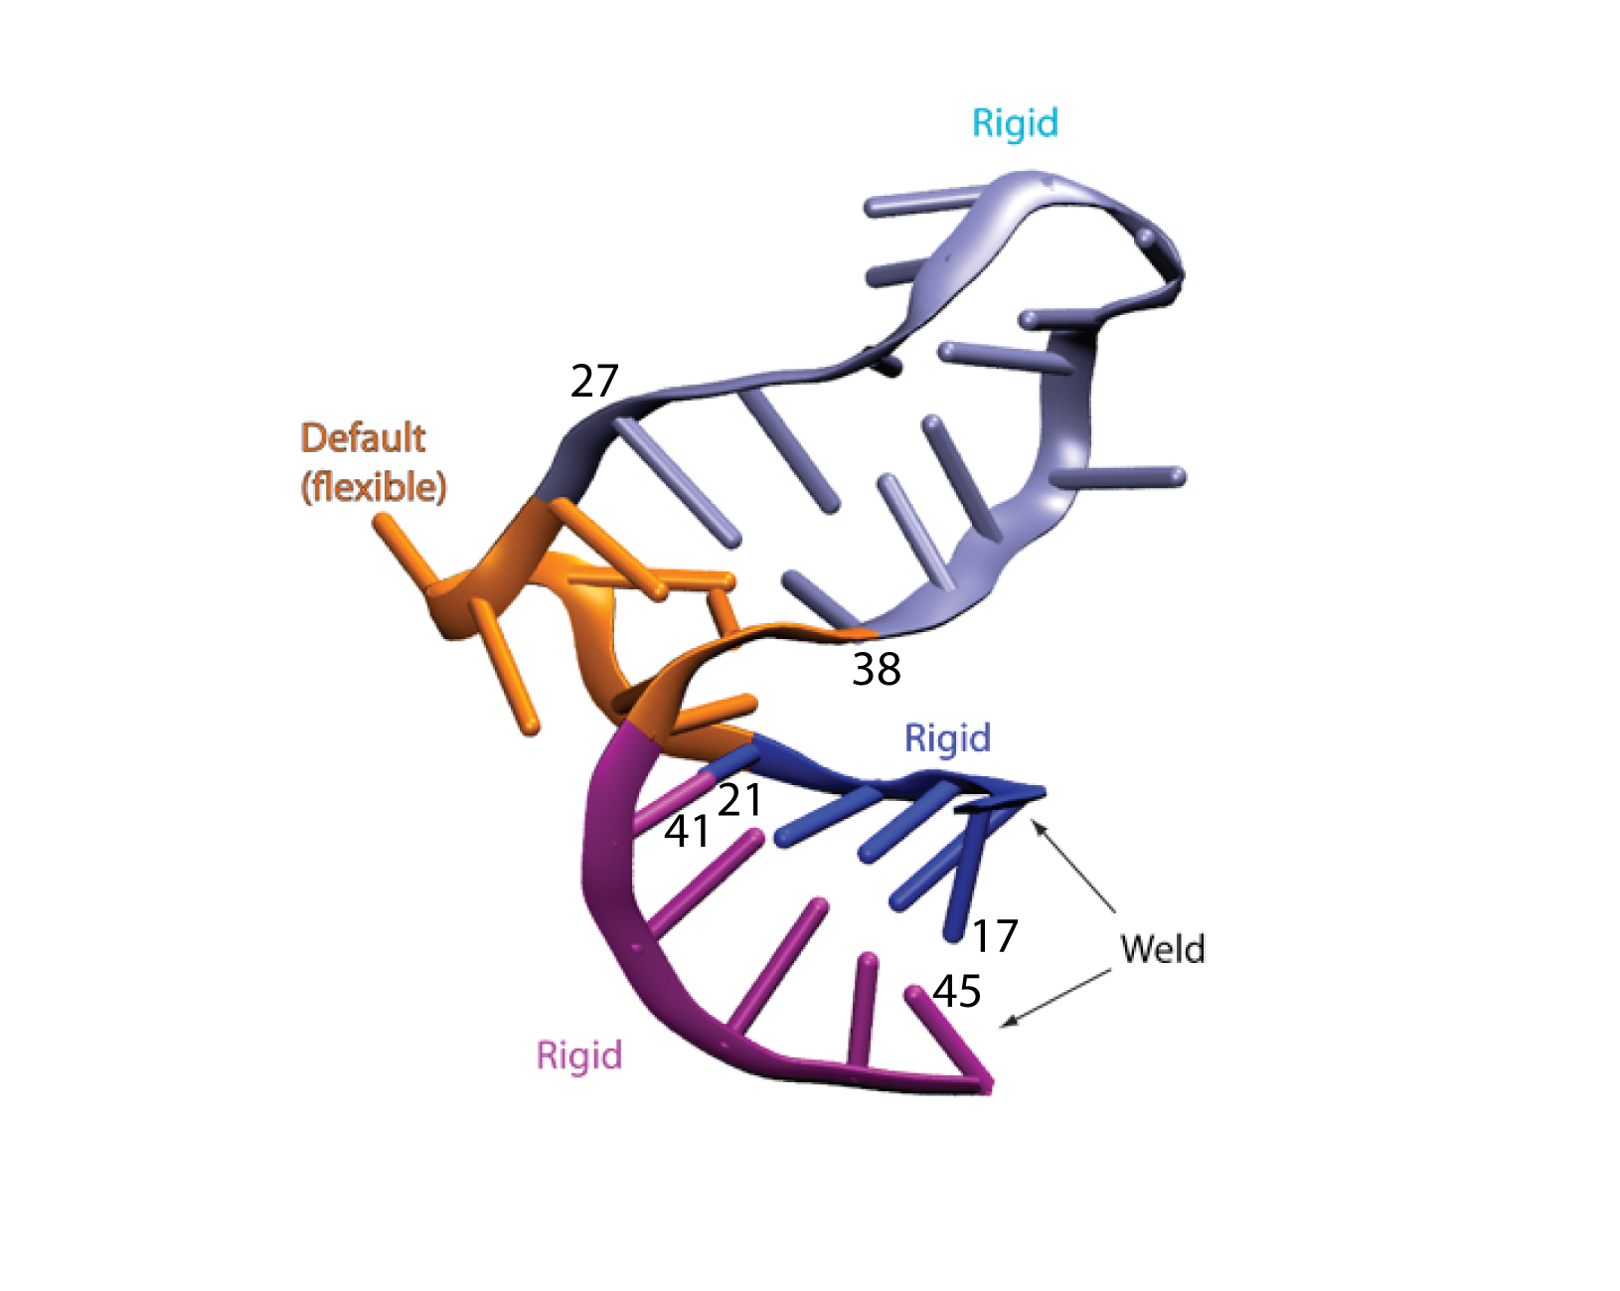

## SelectedAtoms

We use a syntactical variation of the contact command introduced in Exercise 1. Here we use the SelectedAtoms scheme, and also specify the residue range explicitly:

contact SelectedAtoms N FirstResidue LastResidue

Where FirstResidue and LastResidue are self explanatory – but we could just as easily have given residue numbers (including any insertion codes) explicitly – see the *Reference guide.*

## Run example

Make sure you are still in the directory with the *commands.TAR.dat* and the *parameters.csv* files. To do this, in your command prompt/terminal window (see Exercise 0), type:

*(Windows)* dir

*(Mac OS, Linux)* ls

You will see a list of files in your current directory. Make sure you have *commands.TAR.dat* and *parameters.csv*. If not, navigate to the directory with these files (see Exercise 0).

Now, run this example by typing:

*(Windows)* MMB.2\_13.exe -c commands.TAR.dat

*(Mac OS)* ./MMB.2\_13.OSX -c commands.TAR.dat

*(Linux)* ./MMB.2\_13.Ubuntu32 -c commands.TAR.dat

The trajectory from this simulation run is in *trajectory.2.pdb* file. Note the “2” in the file name. Since the first stage in this run was “2,” the corresponding output has a tag of “2” in its file name. Load this trajectory into VMD (see Exercise 0). During the trajectory, you should notice that one part of the structure is rigid and the other part is flexible.

## On your own: Determine the effects of the Weld constraints and rigidification

Try holding the helices together with just base pairing forces rather than constraints. This is a matter of removing the lines specifying the Weld constraints and rigidification. Does the domain structure change much?

## On your own: Turn the RNA into a different 3D structure

Change the sequence and/or constraints and turn the RNA into a different 3D structure, e.g., a hairpin or a pseudoknot.

# Exercise 3: Threading Azoarcus to Tetrahymena Ribozyme P6ab

## Objectives

In this exercise, you will:

* Learn how to use MMB to construct a model using a known RNA structure as a template (this process is known as threading)
* Practice using the AllHeavyAtomSterics contact force
* Learn how to use threading forces

## Specifying the target

The target is the known RNA structure that will serve as a template.

### Read in the PDB file for the target

You will need to read in the PDB file for this RNA (see Exercise 2). In this exercise, you will be using the *1GID.shifted.pdb* file.

In your MMB folder, you should see the following files: *1GID.shifted.pdb* and *commands.P6ab-threading.dat*. If you do not see them, make sure you are in your MMB folder (see Exercise 0).

Copy *1GID.shifted.pdb* to *last.1.pdb* by typing the following in your command prompt/terminal window:

*(Windows)* copy 1GID.shifted.pdb last.1.pdb

*(Mac OS, Linux)* cp 1GID.shifted.pdb last.1.pdb

Open up *commands.P6ab-threading.dat* in a text editor. Verify that firstStage is set to 2 so that the provided PDB file is read in and used by MMB.

### Specify target sequence to match information in the PDB file

In the input parameters file, you will also need to specify a target sequence with a chain ID and residue numbering that matches that of the PDB file. If you open the file *1GID.shifted.pdb* in a text editor, you will see that the first residue is numbered “220” and has a chain ID of “Q.” So, in the command file, you would include the following line:

RNA Q 220 GUCCUAAGUCAACAGAUCUUCUGUUGAUAUGGAU

### Rigidify the target

Lastly, you need to rigidify your target molecule so that it does not move. The threaded chain is the one that will morph so that it matches the target. In this example, the following line would rigidify the target (Tetrahymena ribozyme P6ab):

mobilizer Rigid Q 220 253

## The threaded chain

The threaded chain is the one being mapped onto a known structure.

### Specify the sequence of the threaded chain

In the input parameters file, specify the sequence and first residue number of the chain to be threaded. For the Azoarcus fragment, this is done with the following line:

RNA C 146 CCUAAGGCAAACGCUAUGG

### Account for sterics using AllHeavyAtomSterics Contact forces

Using the contact keyword with AllHeavyAtomSterics results in applying Contact spheres to selected atoms on each residue within the specified range, inclusive.

In this case, we only want to apply steric forces to the threaded chain; if the target chain also had Contact spheres, then the threaded chain would not be able to get close to it. To apply these AllHeavyAtomSterics spheres to all the residues of the Azoarcus fragment, the following line is added to the input parameters file:

contact AllHeavyAtomSterics C 146 164

## Apply forces to pull the corresponding residues together

The threading command is explained in the Reference Guide, in our chapter on “Forces.” In the first line below we are asking for residues 146-150 of the model (“C”) to be aligned with residues 222 to 300 of the template (“Q”). For each pair of corresponding residues, this command looks for all (non-hydrogen) atoms in the first residue which have atoms with the same name in the corresponding second residue. It then applies a spring to pull those two atoms together. The spring has an adjustable force constant, the last parameter (in this case 300):

#Threading forces

threading C 146 150 Q 222 226 300

threading C 160 164 Q 247 251 300

Alternatively, we could have used baseInteraction command with Superimpose edges to perform the threading. Superimpose acts just like the WatsonCrick and other edges, except it tries to enforce *zero* relative translation and rotation between the interacting residues. Thus it will act to align the two, which is what we want in a threading job. In this example, we specify that residue 146 of the Azoarcus fragment should be matched up with residue 222 of the Tetrahymena fragment, and so on. You’ll find this old usage commented out in the input file:

#baseInteraction C 146 Superimpose Q 222 Superimpose Cis

#baseInteraction C 147 Superimpose Q 223 Superimpose Cis

#baseInteraction C 148 Superimpose Q 224 Superimpose Cis

#baseInteraction C 149 Superimpose Q 225 Superimpose Cis

#baseInteraction C 150 Superimpose Q 226 Superimpose Cis

#baseInteraction C 160 Superimpose Q 247 Superimpose Cis

#baseInteraction C 161 Superimpose Q 248 Superimpose Cis

#baseInteraction C 162 Superimpose Q 249 Superimpose Cis

#baseInteraction C 163 Superimpose Q 250 Superimpose Cis

#baseInteraction C 164 Superimpose Q 251 Superimpose Cis

Note that in this syntax, the Cis does not have any physical significance. But glycosidic bond orientation is a required field in the baseInteraction syntax.

## Run example

Make sure you are still in the directory with the *commands.P6ab-threading.dat* and the *parameters.csv* files. To do this, in your command prompt/terminal window (see Exercise 0), type:

*(Windows)* dir

*(Mac OS, Linux)* ls

You will see a list of files in your current directory. Make sure you have *commands.P6ab-threading.dat* and *parameters.csv*. If not, navigate to the directory with these files (see Exercise 0).

Now, run this example by typing:

*(Windows)* MMB.2\_13.exe -c commands.P6ab-threading.dat

*(Mac OS)* ./MMB.2\_13.OSX -c commands.P6ab-threading.dat

*(Linux)* ./MMB.2\_13.Ubuntu32 -c commands.P6ab-threading.dat

The trajectory from this simulation run is in *trajectory.2.pdb* file. Load this trajectory into VMD (see Exercise 0). At the beginning of the trajectory, you should see two distinct structures. Eventually, you should see one end of the Azoarcus fragment appear to attach itself to the Tetrahymena fragment and then gradually “thread” the rest of itself onto Tetrahymena. At the end of the trajectory, you will get a structure like that shown below, where the Tetrahymena target structure is in green and the Azoarcus threading fragment is in blue. Notice that we did the threading even though there are portions of Azoarcus that do not match to any parts of Tetrahymena; we dealt with this by only applying forces to corresponding bases, and leaving the rest alone.

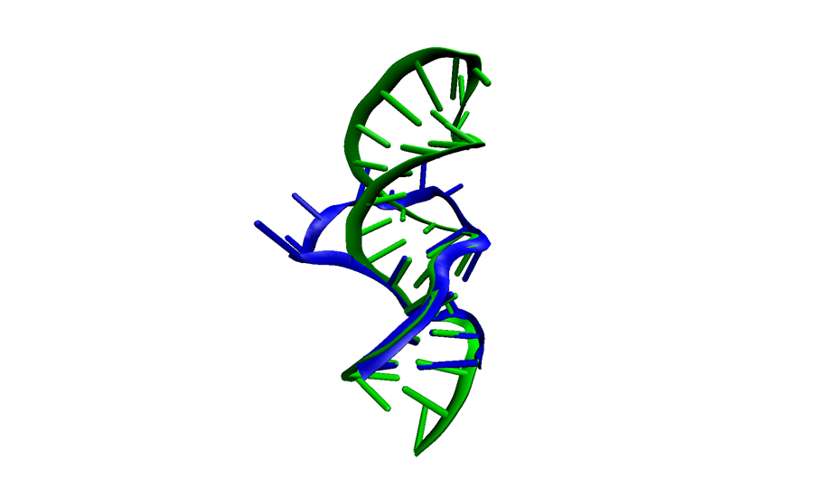

# Exercise 4: Protein threading

## Objectives

In this exercise, you will:

* Learn how to create protein chains
* Practice using the AllHeavyAtomSterics contact force
* Use the threading forces for protein chains

## Specifying the target

The target is the known protein structure that will serve as a template.

### Provide the PDB file for the target

You will need to read in the PDB file for this RNA (see Exercise 2). In this exercise, you will be using the *protein-template.pdb* file.

In your Installation folder, you should see the following files: *protein-template.pdb* and *commands.protein-threading.dat*. If you do not see them, make sure you are in your installation folder (see Exercise 0).

Copy *protein-template.pdb* to *last.1.pdb* by typing the following in your command prompt/terminal window:

*(Windows)* copy protein-template.pdb last.1.pdb

*(Mac OS, Linux)* cp protein-template.pdb last.1.pdb

Open up *commands.protein-threading.dat* in a text editor. Verify that firstStage is set to 2 so that the provided PDB file is read in and used by MMB. There are a some reporting and simulation parameters which you’re by now familiar with, and we’ll skip the explanation of those.

### Start the run

*(Windows)* MMB.2\_13.exe –c commands.protein-threading.dat

*(Mac OS)* ./MMB.2\_13.OSX –c commands.protein-threading.dat

*(Linux)* ./MMB.2\_13.Ubuntu32 –c commands.protein-threading.dat

### Specify template sequence to match information in the PDB file

In the command file, you will need to specify a target sequence with a chain ID and residue numbering that matches that of the PDB file. If you open the file *protein-template.pdb* in a text editor, you will see that the first residue is numbered “94” and has a chain ID of “E.” So, in the command file, we have the following line:

protein E 94 CYDYDAIPWLQNVEPNLRPKLLLKHNLFLLDNIVKPIIAFYYKPIKTLNGHEIKFIRKEEYIS

### Specify model sequence, for which no structural information is available

You will also need to specify a model sequence with a chain ID (here we use “H” as a mnemonic for “human”) and residue numbering which should probably follow some biological convention. We got our sequence from the telomerase database (telomerase.asu.edu):

protein H 522 RSPGVGCVPAAEHRLREEILAKFLHWLMSVYVVELLRSFFYVTETTFQKNRLFFYRKSVE

### Rigidify the template and constrain it to ground

You will need to rigidify the template, but not leave the model flexible. You might also want to constrain the template to ground, though that’s a matter of taste. Anyway, you know how to do this:

mobilizer Rigid E 94 156

constrainToGround E 94

### Align the model and template backbones

Lastly, we will pull the model backbone into structural alignment with the template backbone based on sequence identity. The commands look like this:

threading H 524 543 E 96 115 300.0

threading H 544 580 E 117 153 300.0

The syntax of the threading is in our chapter on “Forces.” In the first line above we are asking for residues 524-544 of the model (“H”) to be aligned with residues 96 to 116 of the template (“E”). How do we know that these residues should align? From the sequence alignment (again, telomerase.asu.edu). There is a single-residue insertion in chain E -- residue 116. Correspondingly, we do not align this residue with any on chain H.

The threading command is a macro that issues the atomSpring command, once for each pair of atoms with the same name, in each pair of corresponding residues.

### Apply sterics to the model chain

Lastly, we want sterics for the model – but not for the template. We use AllAtomSterics, which place one sphere of radius excludedVolumeRadius and stiffness excludedVolumeStiffness to every atom in every involved residue. We could have used AllHeavyAtomSterics, which skips the hydrogen atoms – on the upside this would save compute time but on the downside some hydrogens would be close to other atoms. It’s a judgement call.

contact AllAtomSterics H 522 580

.. And we’re done! The output should look something like this:

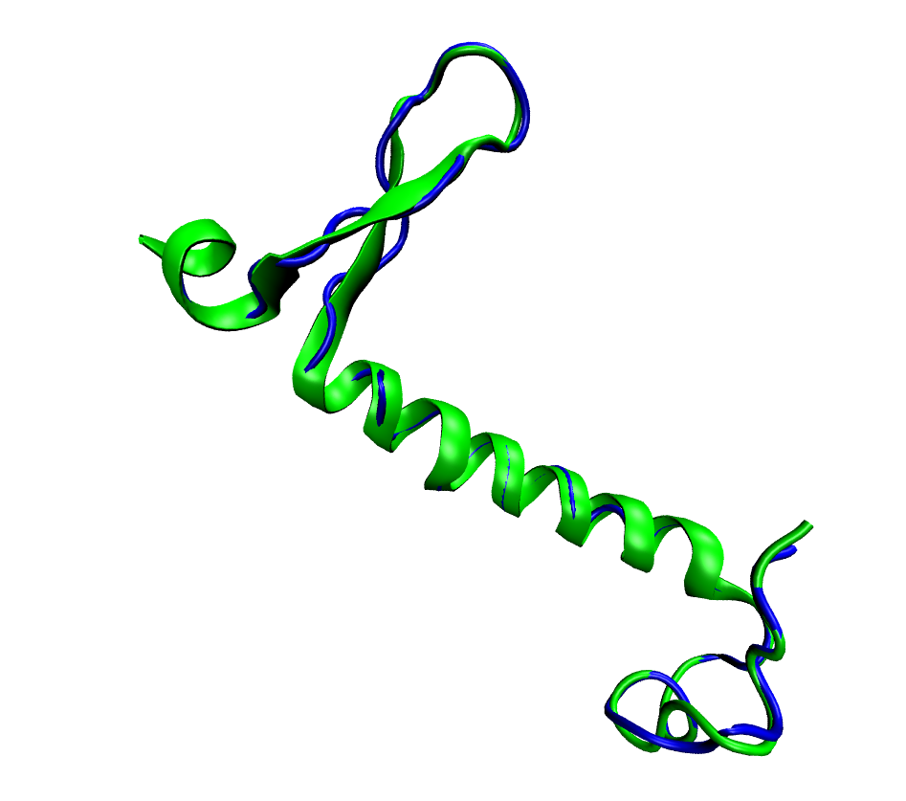

Where the template is in green and the model is in blue.

# Exercise 5: Protein morphing

## Objectives

Using what you learned earlier, you will learn to generate a putative trajectory between two known conformations of a macromolecule, a technique known as *morphing*. This will give you practice in:

* Using the threading command (for a slightly different purpose).
* Using the mobilizer command.
* Using the readAtStage .. readBlockEnd conditional blocks.
* Adjusting the reportingInterval

## Introduction

We will morph Glutamine Binding Protein (GlnBP), a molecule somewhat larger than any we’ve worked with up to now. GlnBP is a domain hinge bending protein, meaning that it has stable structural domains connected by a flexible hinge. We will take advantage of this property by rigidifying the two domains of the model for time savings. This will get the model most of the way towards the target molecule. As an exercise, in a final stage you will leave the model flexible to complete the morph. You will see that this exercise is like the preceding threading exercise, with one key difference: in morphing, not only the target’s, but also the model’s initial atomic coordinates are known.

Morphing is an old technique, and many good servers (e.g. molmovdb.org) and programs are available. You will see that selective rigidification offers the advantage of speed. In published work, we have morphed the entire ribosome, including all 50 protein subunits, in about 2.5 hours of computer time. Using MMB also gives you more control over precisely how the morph is done. The price of all this is that the process is bit more manual, but you will learn how to do it here.

## Preparing the input structure file

As in the previous exercise, we will put out given coordinates in last.1.pdb. However this time we have coordinates for the model (1GGG.short.pdb) as well as the target (1WDN.short.pdb), and we will have to put both in the input structure file. In Mac and Linux this is easy:

*(Mac OS, Linux)* cat 1GGG.short.pdb 1WDN.short.pdb > last.1.pdb

In Windows, you will probably have to do this by cutting and pasting using your text editor.

## Start the run

Start the job as usual:

*(Windows)* MMB.2\_13.exe –c commands.protein-morphing.dat

*(Mac OS)* ./MMB.2\_13.OSX –c commands.protein-morphing.dat

*(Linux)* ./MMB.2\_13.Ubuntu32 –c commands.protein-morphing.dat

## Examine the input file

As in the previous exercise, we have model and target sequences:

# Model, 1GGG

protein A 5 LVVATDTAFVPFEFKQGDLYVGFDVDLWAAIAKELKLDYELKPMDFSGIIPALQ TKNVDLALAGITITDERKKAIDFSDGYYKSGLLVMVKANNNDVKSVKDLDGKVVAVKSGTGSVDYAKANIKTKDLRQFPNIDNAYMELGTNRADAVLHDTPNILYFIKTAGNGQFKAVGDSLEAQQYGIAFPKGSDELRDKVNGALKTLRENGTYNEIYKKWFGTE

# Target, 1WDN

protein B 4 KLVVATDTAFVPFEFKQGDLYVGFDVDLWAAIAKELKLDYELKPMDFSGIIPAL QTKNVDLALAGITITDERKKAIDFSDGYYKSGLLVMVKANNNDVKSVKDLDGKVVAVKSGTGSVDYAKANIKTKDLRQFPNIDNAYMELGTNRADAVLHDTPNILYFIKTAGNGQFKAVGDSLEAQQYGIAFPKGSDELRDKVNGALKTLRENGTYNEIYKKWFGTEPKQ

Chain B has some residues at the N- and C-termini which don’t exist on chain A. However you can verify that residue A 5 corresponds to B 5, and so on all the way to residue 224. So we will pull those residues together like this:

threading A 5 224 B 5 224

We will be doing this in two stages – one for rigid body alignment and another for semi-rigid morphing, as we will explain:

firstStage 2

lastStage 3

Initially we will use a reportingInterval of 10 ps, but you may reduce this later.

reportingInterval 10.0

numReportingIntervals 25

We will be constraining residues to ground later, so let’s keep turn off the rigid body momentum removal:

removeRigidBodyMomentum false

The template molecule will be rigid throughout this exercise:

mobilizer Rigid B 4 227

Our first task is to rigidly align the model and template, since they start out spatially quite separated. We will do this at stage 2. At this stage, the model will be completely rigid:

# Rigid alignment stage

readAtStage 2

mobilizer Rigid A 5 224

readBlockEnd

Then at stage 3 we will do the semiflexible morphing. We know from published work that there is a hinge at residues 88-89 and 181-183. So we rigidify the thus-defined structural domains, and constrain one of them to the ground:

readAtStage 3

mobilizer Rigid A 5 87

mobilizer Rigid A 90 180

mobilizer Rigid A 184 224

constrainToGround A 5

constrainToGround A 195

readBlockEnd

Stages 2 and 3 should be done by now. Open trajectory.2.pdb and trajectory.3.pdb in your molecular viewer. You should see something like the following:

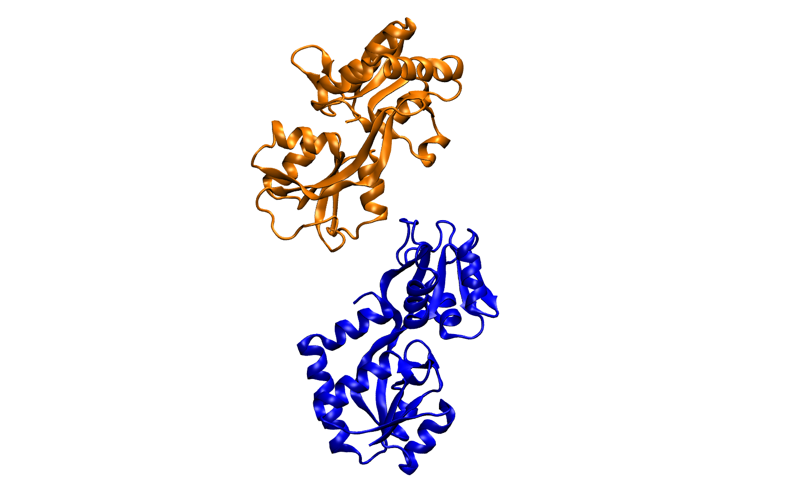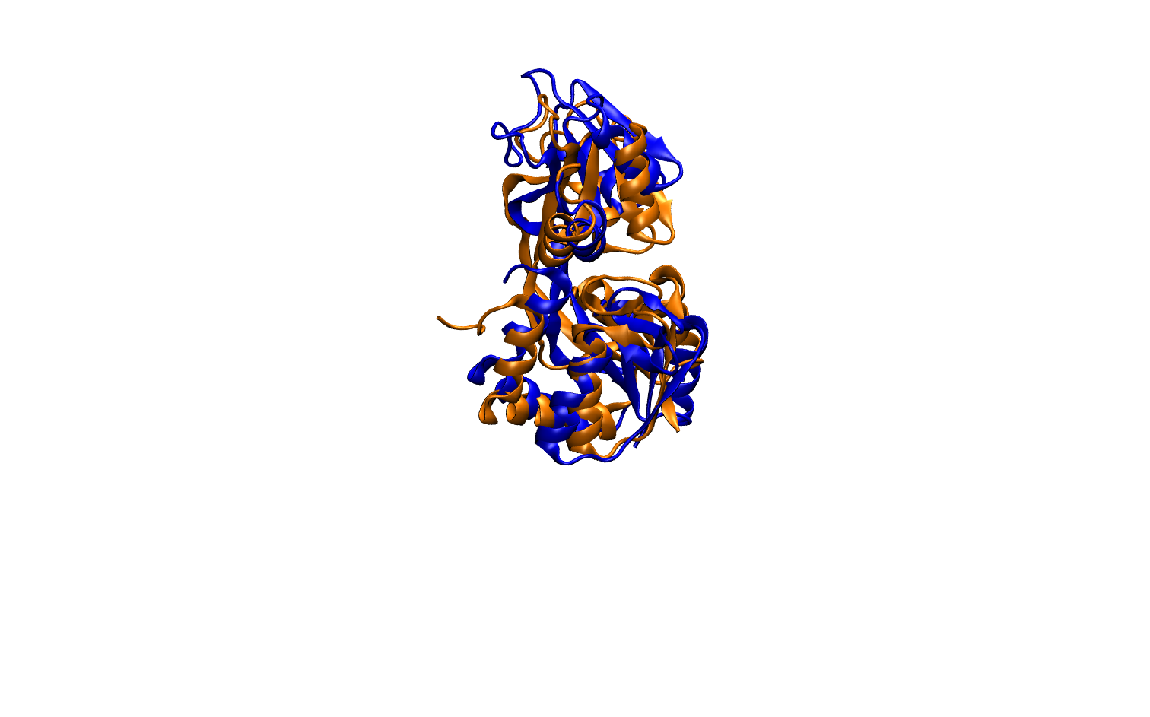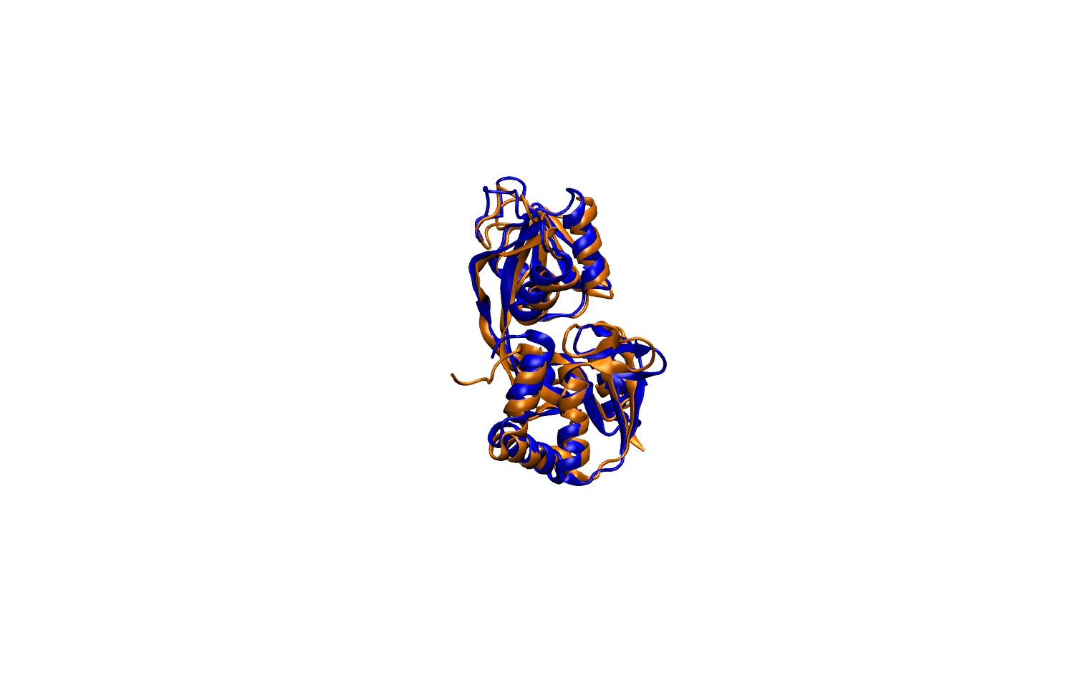

Left: Model (blue) and target (gold) in their initial, separated positions. Center: Model and target rigidly aligned. Right: Model semiflexibly aligned with target.

## On your own: complete the morph with a fully-flexible alignment

You will notice that at the end of stage 3, the model is not fully aligned with the target. In this exercise, you will make the model fully flexible. You should end up with something like the image below.

Hints:

1. You will need to do this at stage 4.
2. Check that the model is fully flexible.
3. The simulation will be slower now, so reduce the reporting interval by ~ 10X.

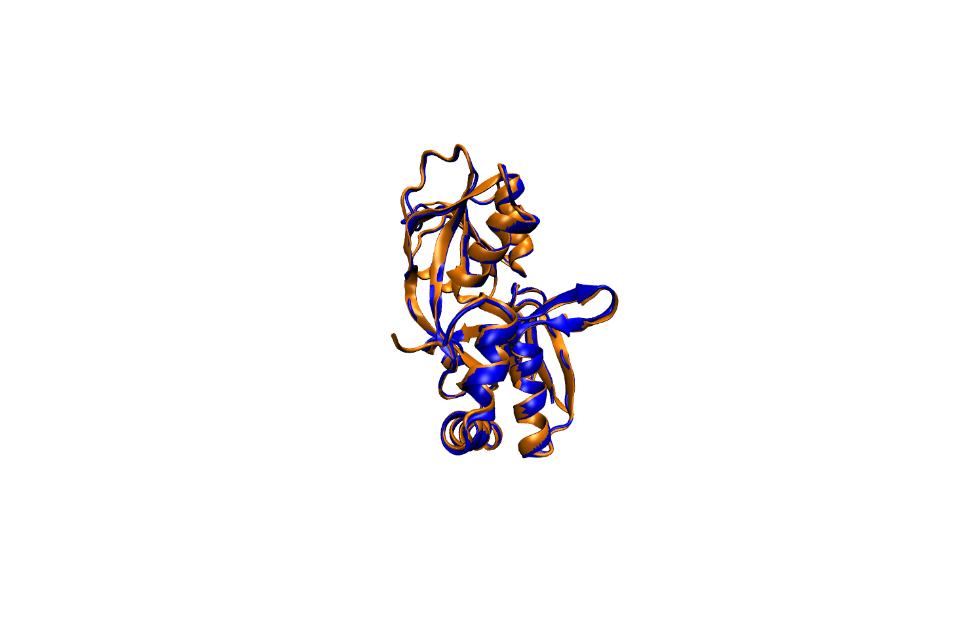

# Exercise 6: Efficiently generate alternate protein conformations

## Objectives

In exercise 2 you learned how to use rigidification, randomizeInitialVelocities, and sterics to do thermal exploration of RNA conformations. In this exercise you will do the same for protein. Specifically this will teach you:

* The ProteinBackboneSterics sterics type arameter
* An efficient way to generate alternate conformations of proteins.
* Doing alignments and RMSD calculations in VMD

## Introduction

There are many reasons to generate alternate conformations of proteins. Maybe you want to make an ensemble for protein-protein or protein – small molecule docking. Maybe you are trying to elucidate functional mechanisms. In any case, generating alternate conformations is often done by randomly moving atoms, or by using normal modes. These methods do not conserve the correct domain structure. For many hinge bending proteins, domain structure is conserved throughout the motion to some degree. In this exercise, you will find the alternate conformations that are possible under the assumption that only the hinge residues are flexible. You will use the ProteinBackboneSterics scheme, in which only the N, Cα, and C atoms get collision detecting spheres, to avoid generating clashing structures.

## The command file

Open the file commands.GlnBP-thermal-exploration.dat. Most of the contents will be familiar to you. You haven’t used this sterics parameter before:

contact ProteinBackboneSterics A 1 220

The hinge residues are 89-90 and 180-182:

mobilizer Rigid A 1 88

mobilizer Rigid A 91 179

mobilizer Rigid A 183 220

The first and third fragments comprise a discontinuous domain that we will fix to ground:

constrainToGround A 1

constrainToGround A 220

Leaving the second domain all the motion permitted by the hinge (and sterics).

## Run MMB

Copy 1GGG.short.pdb to last.1.pdb . The former is an open form of Glutamine Binding Protein (GlnBP).

Now run MMB against the command file, e.g.:

./MMB.2\_13.OSX –c commands.GlnBP-thermal-exploration.dat

./MMB.2\_13.Ubuntu32 –c commands.GlnBP-thermal-exploration.dat

This will create a trajectory.2.pdb .

## Analyze the conformational coverage

The idea behind a thermal exploration of this nature is that your ensemble may contain an alternate conformation which exists under certain conditions. You would not know this alternate conformation in a practical situation, so to have more confidence that your sampling is reasonably comprehensive, you might see how often the trajectory returns to its initial conformation, within perhaps 2Å RMSD or so. Actually we calculate this RMSD only over the mobile domain (in our case residues 87 to 175), a quantity Ruben Abagyan calls sRMSD. You can easily calculate this sRMSD using VMD. A sample script follows:

# loop a variable i from 1 to 269:

for {set i 1} {$i < 269} {incr i} {

# select residues 91 to 179 of the reference structure (frame 0, or the starting conformation). “atomselect 0” means choose the first (in this case, the *only*) trajectory that is loaded in VMD. Put this structure in a variable called sel0:

set sel0 [atomselect 0 "resid 91 to 179" frame 0];

# create a selection set (sel1) consisting of the same domain in frame i :

set sel1 [atomselect 0 "resid 91 to 179" frame $i];

# compute the RMSD between sel0 and sel1 :

set my\_rmsd [measure rmsd $sel0 $sel1] ;

# print the RMSD :

puts $my\_rmsd

# end the loop:

}

You can put this script in a file and read it in. It’s pretty easy just to dump it as a single line into the TK console (Extensions -> TK Console), like this:

for {set i 1} {$i < 269} {incr i } { set sel0 [atomselect 0 " resid 91 to 179 " frame 0 ]; set sel1 [atomselect 0 " resid 91 to 179 " frame $i]; set my\_rmsd [measure rmsd $sel0 $sel1] ; puts $my\_rmsd }

You will get a stream of sRMSD numbers. Cut and paste these into your favorite spreadsheet. You should be able to make a graph like this:

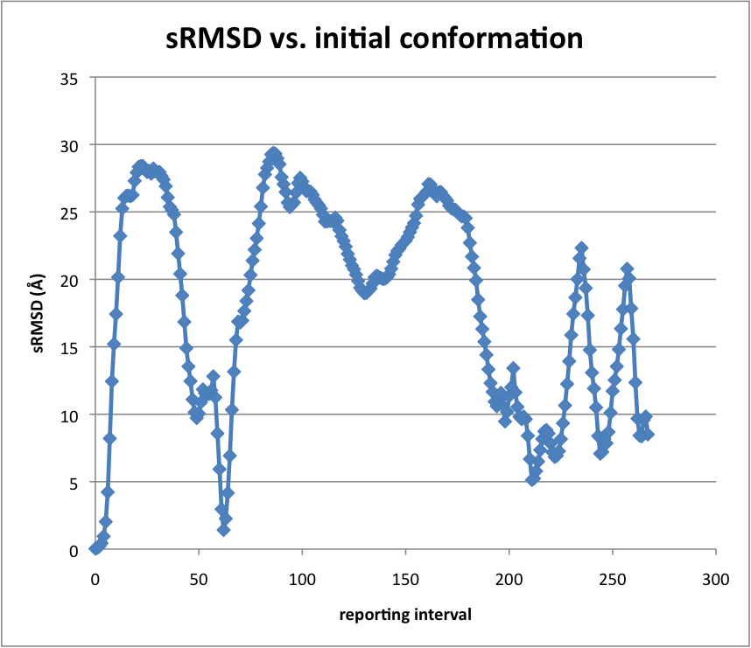

Note the sRMSD dips below 5Å a couple of times. You can run this longer if you are not convinced you’ve gotten good sampling. You can also compare this to the closed structure (PDB ID: 1WDN). That requires some aligning and careful definition of sel0 and sel1.

# Exercise 7: Solve protein structure by NMR constraints

## Objectives

You've learned a lot so far. You’ve learned how to do everyday modeling tasks such as morphing, conformational sampling, and threading. You learned how to turn base pairing contacts into 3D structure of RNA. I will progressively make things more challenging for you. In this chapter you will learn how to turn distance constraints, such as can be obtained from NMR experiments, into 3D structure with a little help from the Amber99 force field. This will involve the following tasks:

* Use the atomTether command
* Turn a list of distance constraints into MMB commands
* Turn on the Amber99 force field for the entire system

## Instructions

You are reasonably far along now, so you don’t need detailed instructions for everything – thus I’ll skip a few basic steps. You will need to turn on all terms of the force field:

globalAmberImproperTorsionScaleFactor 1

globalBondBendScaleFactor 1

globalBondStretchScaleFactor 1

globalBondTorsionScaleFactor 1

globalCoulombScaleFactor 1

globalVdwScaleFactor 1

In this exercise we are turning on physics everywhere. So you can just leave physicsWhereYouWantIt at the default value, or set it explicitly:

physicsWhereYouWantIt FALSE

You might want to use a temperature that leads to some oscillation about equilibrium:

temperature 100

You will also need the sequence. You can extract it from 1UAO.short.pdb using the extract\_FASTA.awk script.

Lastly, you will want to add the distance constraints. Let’s say you know that on chain A, atom 2HA of residue 1 is at most .45nm from atom HE3 of residue 9. The way you would enforce that is:

atomTether A 1 2HA A 9 HE3 .4500 300.00

where the last (optional, defaults to 30 if left out) number specifies the spring constant of a spring that will pull the two atoms together if they’re more than 4.5Å apart. I suggest making this 300 for this application, because empirically I’ve found this is strong enough.

Unfortunately the people that made the 1UAO structure didn’t use the PDB atom naming convention. So we will have to correct the atom names. The following substitutions are necessary:

Everywhere:

HA2 2HA

HB2 2HB

HG2 2HG

HG21 1HG2

HG22 2HG2

HG23 3HG2

Residue 4 only:

HD2 2HD

If you want to skip this hassle, just use 1UAO.atoms-renamed.pdb.

I’ve included a list of distance constraints called 1UAO-disre-simple.txt . Try to use it to generate the atomTether commands. You may find the parse-restraints.pl script useful.

The parse-restraints.pl script looks like this:

# perl ./parse-restraints.pl 1UAO-disre-simple.txt 1UAO.short.pdb

#open the restraints file (first argument):

open RESTRAINTS, $ARGV[0] or die $!;

#load restraints into an array:

@restraints = <RESTRAINTS> ;

close (RESTRAINTS);

int r;

#for each restraint:

for ($r = 0; $r < scalar(@restraints); $r++)

{

#first atom number

int $i ; $i = substr($restraints[$r],0,3);

#second atom number

int $j ; $j = substr($restraints[$r],10,3);

#distance:

int $dist ; $dist = substr($restraints[$r],20,5);

# initialize to “\*” so we can later tell if not read

$atomName1 = "\*";

$atomName2 = "\*";

int $residueNumber1; $residueNumber1 = -1;

int $residueNumber2; $residueNumber2 = -1;

$chain1 = "A";

$chain2 = "A";

#open PDB file (second argument)

open PDB, $ARGV[1] or die $!;

#for each line in PDB file:

while (<PDB>) {

#parse the atom number

int $PDBatomNumber; $PDBatomNumber = substr($\_,6,5);

#if first atom number matches an atom number in the PDB file

if ($PDBatomNumber == $i) {

# extract atom name, residue number, and chain ID:

$atomName1 = substr($\_,12,4);

$residueNumber1 = substr($\_,22,4);

$chain1 = substr($\_,21,1);

}

if ($PDBatomNumber == $j) {

# extract atom name, residue number, and chain ID:

$atomName2 = substr($\_,12,4);

$residueNumber2 = substr($\_,22,4);

$chain2 = substr($\_,21,1);

}

}

#print out MMB atomTether commands:

print "atomTether $chain1 $residueNumber1 $atomName1 $chain2 $residueNumber2 $atomName

2 $dist \n";

}

#done!

You will also need to convert the distances from nm to Å. While you’re add it, set the spring constant to 300.0.

It’s best to make your own MMB input file. But if you just want the right answer, look at the provided commands.NMR.dat .

## Results

Your structure should agree with the published one (1UAO.short.pdb in your MMB distribution) within about 1.3Å RMSD.

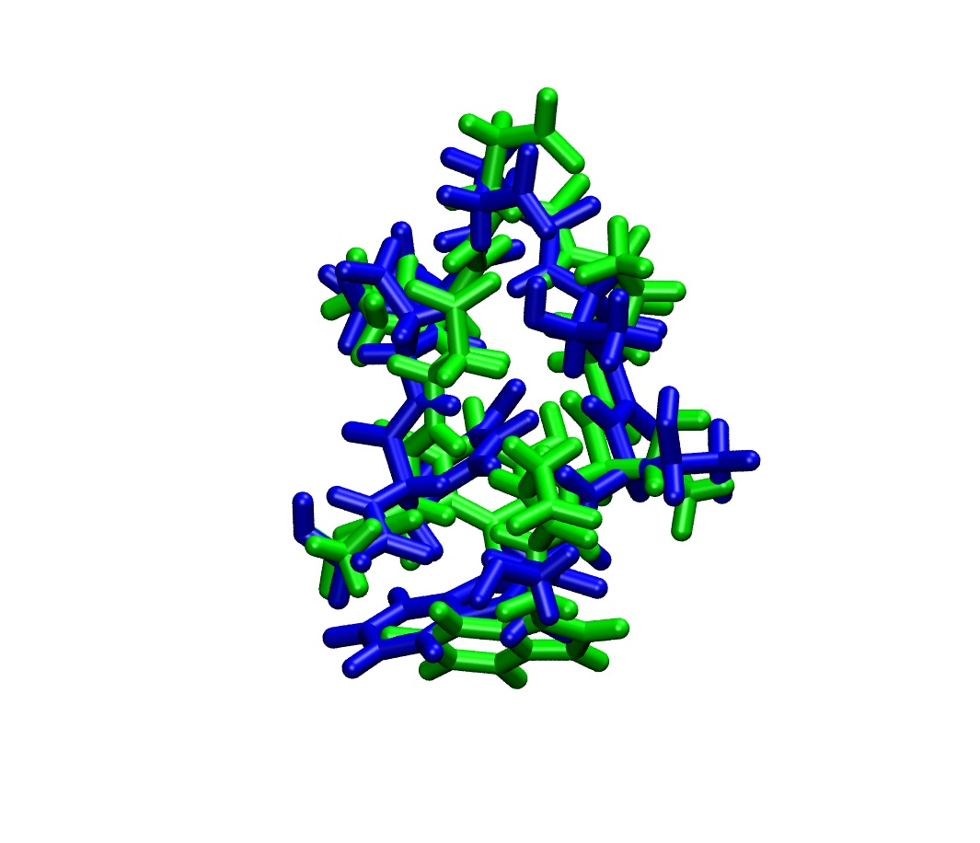

# Exercise 8: Fitting to electron density maps

## Objectives

You may have found some of the preceding exercises redundant in some sense, perhaps repeating in protein what was already done in RNA, etc. Perhaps you could be forgiven for falling asleep. In this exercise we will do something completely different – fitting atomic coordinates to electronic density maps, which could have come from a cryo-electron microscopy (CryoEM), small-angle X-ray scattering, crystallographic, or other experiment. The skills you picked up in previous lessons about selective rigidification, constraints, forces, even “Physics where you want it” or straight-out all-atoms force fields will serve you well as you efficiently build 3D models. The following parameters will be new to you:

* densityForceConstant
* densityFileName

The following command will also be new:

* fitToDensity

If you are taking our Computational and Systems Biology course at Uppsala University, or just want a challenge, you can also learn how to extract the sequence (in single-letter code) from and to renumber the residues in a PDB file. Hopefully you will also gain some insight into the flexibility of the ribosome.

## Introduction

Electron density maps can be produced by cryo-electron microscopy (Cryo-EM), Small Angle X-ray Scattering (SAXS), X-ray crystallography, and other means. They are an important source of structural information. However they are hard to interpret without solving for the nuclear positions. Most of the structures in the PDB were once electronic densities, and have been fitted with nuclear positions.

There are many fine pieces of software available for fitting 3D structure to density maps. Here at Uppsala, “O” is quite popular. I will not attempt a full review of such programs here. Our approach, however, follows the work of Klaus Schulten, who invented Molecular Dynamics Flexible Fitting (MDFF). In MDFF, the atoms in the molecule or complex are subject to a conventional Molecular Dynamics force field, plus an additional force which is proportional to the atomic mass and the gradient of the electronic density. In MMB, we adapt this force as follows:



Where *i* is the atom index, mi is the mass of atom *i*, is the electronic density at the nuclear position of atom *i*, A is a user-adjusted scaling factor, and  is the gradient operator. Accordingly,  is the density-derived force vector applied to atom *i*. This is computed for and applied to every atom *i* in the system.

In this exercise, you will specify the sequence of a tRNA molecule, read in an initial set of nuclear coordinates, read in the density map of the ribosomal hybrid state, and then fit the tRNA molecule into the density. So let’s get started!

## Run MMB

In a practical situation, preparing a good starting model is an important part of the work. I used Venki Ramakrishnan’s structure of the *T.thermophilus* ribosome in the classical state (2J00, 2J01, 2J02, 2J03), which I then semiflexibly morphed to match Jamie Cate’s “R2” intermediate structure. You can read all about the why and wherefore in my 2011 paper in *Proceedings of the Pacific Symposium on Biocomputing*. Anyway, I took the morphed structure and re-centered it using COLORES, which is part of the Situs package. This is easier than it might sound, but you won’t have to do any of it, just use the coordinates in tRNA.pdb, which is in your MMB 2.4 distribution. Issue:

cp tRNA.pdb last.1.pdb .

Unfortunately this will actually take some time to converge. So start it now, so at least it will run for a couple of minutes while we finish going through the input file. Issue:

./MMB.2\_13.OSX –c commands.tRNA-fitting.dat

./MMB.2\_13.Ubuntu32 –c commands.tRNA-fitting.dat

Depending on your OS. Note that MMB 2.4.1 has a density fitting algorithm that is a full 10X faster than MMB 2.4! So make sure you are using at least MMB 2.4.1 for this exercise.

## The command file

We first instantiate a tRNA molecule:

RNA V 5 CGCGGGAUGGAGCAGCCUGGUAGCUCGUCGGGCUCAUAACCCGAAGGUCGUCGGUCAAAUCCGGCCCCCGCAA

If you don’t have the commands.tRNA-fitting.dat file, you can extract the sequence from a structure file that contains only the tRNA, using e.g. awk –f extract-FASTA.awk <PDB file> . You will find extract-FASTA.awk in your 2.4.1 distribution.

Next we rigidify the tRNA fully:

mobilizer Rigid V 5 77

We have to turn off the rigid body momentum remover, since this would always be trying to recenter the molecules:

removeRigidBodyMomentum false

As you recall from our definition of  above, the scaling factor *A* is user-adjustable. In the command file, *A* is called densityForceConstant. Make this factor too small, and the fitting will take forever. Make it too big, and the molecule might fly out into deep space. Turns out it’s probably best to leave it at the default value of unity:

densityForceConstant 1.00

Now we specify the name of the electron density file, which has to be in XPLOR format:

densityFileName ./tRNA.xplor

Then we activate the density-based force field for chain V:

fitToDensity V

Note that we could just as easily have issued:

fitToDensity V FirstResidue LastResidue

(which does exactly the same thing), or:

fitToDensity

(which fits all chains in the system, which in this case is the same thing)

..I just wanted to make sure you understand the polymorphism of this command.

The rest of the parameters will be familiar to you.

temperature 1

numReportingIntervals 100

reportingInterval .01

firstStage 2

lastStage 2

## View the results

VMD can display density maps. So read in tRNA.xplor. I rendered this using “Solid surface.” Then read trajectory.2.pdb as a new molecule. You should be able to watch the tRNA move into its corresponding density. It should look something like this:

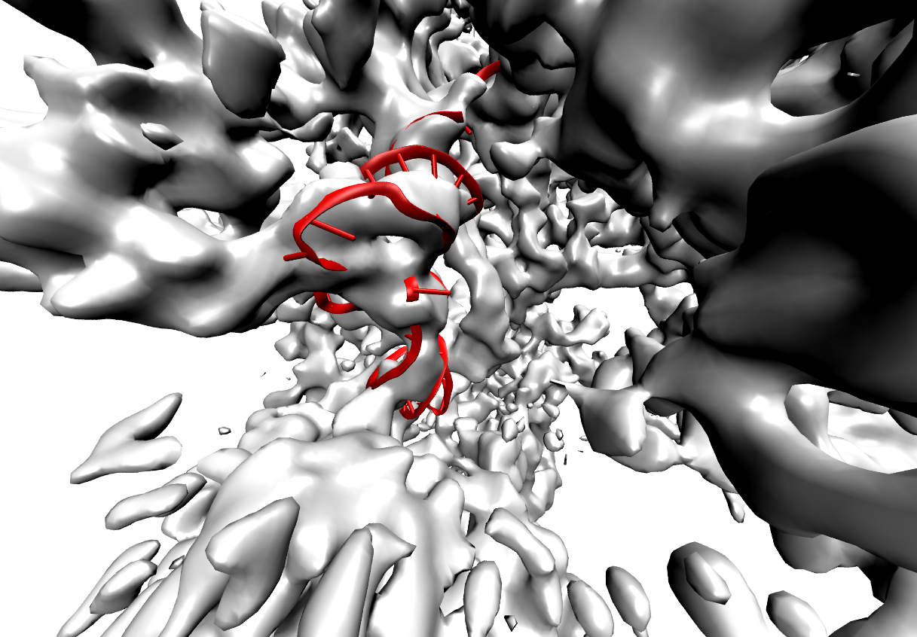

## On your own

We just fitted the P/E site tRNA into the tRNA density map. If you want to fit a bigger subunit, try 16S. You can download the emd\_1315 density map and fit the 16S from 2AVY (provided, or get from the PDB). You will need to extract the sequence of this subunit, and make everything but the neck region Rigid. You may consider the neck region to consist of residues 903 and 1373. Make sure you Weld together fragments of any discontinuous domain.

# Virtual assembly of a protein-DNA complex

Contributed by Erik Marklund

## Objectives

Quite often a good experimental structure model for the particular biomolecule that you are to study is not available under the specific conditions that you demand. For instance, a protein may have been crystallized with the “wrong” ligand, lacking one or a few domains, etc. In such cases the combined data from several experiments can still be used to create a reasonable structure model that can e.g. be used for subsequent molecular dynamics. In this exercise you will see an example of how an existing protein structure model can be used in conjunction with sequence data to produce a model of a related protein with maintained protein-ligand interactions. There are no new commands in this exercise, but the alignment will go beyond the ordinary use of proteinThreading.

## Introduction

The tetracycline repressor (TetR) regulates the genes for tetracycline resistance in bacteria. It is a commonly used system for conditional gene expression and has a high affinity for its operator, *tetO*. There is a X-ray crystallographic structure of operator-bound TetR class D (TetRD) in the protein databank (id. 1QPI), but not for the related TetR class B (TetRB). Their high level of sequence similarity, however, allows for structural alignment of TetRB onto TetRD to yield a structure model of TetRB. Because of the specific interaction with DNA the side-chain conformations of the DNA-binding regions require special attention.

## Run MMB

The input structure file (1QPI) requires little preparation. It contains one monomer from a homodimer and one strand from a double stranded DNA helix. The crystallographic symmetry found in the pdb file can be used at a later point to generate the homodimer bound to the double stranded DNA helix. Because of that we will only perform a structural alignment of a monomer here.

Use the structure model of TetRD as an input file:

cp TetR.pdb last.1.pdb .

Then execute MMB to do the actual alignment:

./MMB.2\_13.OSX –c commands.TetR\_threading\_TUT.dat

./MMB.2\_13.Ubuntu32 –c commands.TetR\_threading\_TUT.dat

(depending on your OS). This will thread the TetRB polypeptide chain onto the TetRD structure while maintaining the side chain interactions with DNA.

## The command file

First we set up the environment and instantiate the TetRD and TetRB monomers and the DNA:

firstStage 2

lastStage 2

reportingInterval 1.0

numReportingIntervals 50

temperature 1.0

removeRigidBodyMomentum false

# TetR class D, bound to DNA

protein A 4 LNRESVIDAALELLNETGIDGLTTRKLAQKLGIEQPTLYWHVKNKRALLDALAVEILARHHDYSLPAA...

# TetR class B, no structure

protein B 4 LDKSKVINSALELLNEVGIEGLTTRKLAQKLGVEQPTLYWHVKNKRALLDALAVEILARHKDYSLPAA...

# DNA

RNA M 1 CCUAUCAAUGAUAGA

RNA N 1 UCUAUCAUUGAUAGG

Perhaps you notice the high sequence similarity of the regions shown above. The structure of TetRD has some stretches of residues that were not resolved in the experiment. The TetRB sequence contains the corresponding residues and has additional insertions that will be part of the final structure model. This means, however, that care must be taken to align the right parts of TetRB to TetRD, as there is not a one-to-one mapping of all residues in the two sequences. The DNA molecules (here instantiated as RNA for technical reasons) are not necessary for the alignment, but make the final output more comprehensive.

Let’s set up the threading of the backbone:

threading A 4 155 B 4 155 300.0

threading A 156 198 B 169 211 300.0

Here the insertions create a discrepancy between the two sequences in terms of residue numbering, as discussed previously. The same thing affects the mobilizers that keep most of the proteins rigid throughout the threading:

mobilizer Rigid A 4 198

mobilizer Rigid B 4 22

mobilizer Rigid B 30 34

mobilizer Rigid B 50 155

mobilizer Rigid B 169 211

mobilizer Rigid M 1 15

mobilizer Rigid N 1 15

The mobilizers above are further complicated by the fact that sidechains that make DNA interactions can not be kept rigid, or their final conformations will be off with respect to the DNA. Therefore we have split up one rigid part into several shorter ones.

We anchor TetRD and the DNA to the ground:

constrainToGround A 4

constrainToGround M 1

constrainToGround N 1

## View the results

Fire up your molecular viewer of choice to inspect your new structure model. last.2.pdb only contains the monomeric protein and single stranded DNA. Hence you will need to make use of the crystallographic symmetry information that is contained in the input structure file.

### Symmetry expansion with PyMOL

Copy the CRYST1 record from last.1.pdb and the coordinates from last.2.pdb to a new file:

grep CRYST last.1.pdb > TetRB\_threaded.pdb

cat last.2.pdb >> TetRB\_threaded.pdb

In PyMOL you can now make a symmetry expansion. Open PyMOL, load the file TetRB\_threaded.pdb, and execute symexp:

Load TetRB\_threaded.pdb

symexp S\_, TetRB\_threaded, all, 1.5

This generates symmetry related copies of the monomeric protein and DNA locally. Note that this command is likely to create more copies than you need, so a few newly generated objects may need to be deleted from the selections/objects panel to the right. Once you have the homodimer you will be able to see if the inserted loops cause any clashes between the monomers that may need further processing. As you will see, the inserted loops are nicely situated in regions that are not occupied by any other atoms, so the entire structure is a plausible structure model of the TetRB-operator complex

The protein-DNA interface of a structurally aligned TetRB homodimer. The homodimer was constructed from the monomeric protein and DNA with the help of the symexp command in PyMOL. Not only is the structure model devoid of side-chain clashes; the specific interactions with DNA were reconstituted in the threading process.

### Symmetry expansion using other tools

Unfortunately, VMD currently lacks the capability to create the full homodimer directly from the crystallographic symmetry information contained in the pdb file. There are other tools at our disposal, however. Examples of such are XPAND (<http://xray.bmc.uu.se/usf/>) and CCP4 (<http://www.ccp4.ac.uk/>), both of which are free to use. Unfortunately, neither XPAND nor CCP4 are guaranteed to work out of the box, but if either of them is already present on your system you could try to make use of it. Finally, there is a web service – Quat (<http://sysimm.ifrec.osaka-u.ac.jp/pdb_quat/)> – that can do expansions according to both crystallographic and non-crystallographic symmetry. Before submitting your structure to Quat it is strongly recommended that you remove TetRD from the pdb file! Quat may destroy the chain labeling, so it’s better to have as few chains as possible before submitting it. For this reason you may choose to also omit the DNA from the Quat input file since it is already symmetry expanded. Inspect the structure afterwards to make sure that the symmetry expansion produced sensible copies!

In principle the symmetry operations can be done in VMD with the help of rotations and translations, but requires some level of familiarity with the crystallographic space groups. In this case the other monomer(s) can be generated by rotating all atoms 180 degrees around the y-axis followed by translation by half a unit cell along the z-axis. This can also be accomplished by putting your favorite scripting language to good use.